**Assumptions:**

* You already have installed and running VariaMos web -> <https://github.com/SPLA/VARIAMOS-WEB>
* You already have installed and running VariaMos services -> <https://github.com/SPLA/VARIAMOS-SERVICES>

**Test (first it is important to test the connection between both projects).**

1. Go to <http://localhost:8080/variamosweb/#/models/feature> and create a very simple feature model.
2. Click BackEnd -> BackEnd setup (menu option). Put the backend url project (for example: <http://localhost:8090/VariaMosServices/>)
3. Click Verification -> Test sending the model (menu option). If appears a popup saying “XML code received by the server”, it means that the communication between both projects is working properly.
   1. You can also check the Eclipse console and it will display the XML code of the drawed model (sent by the VariaMos web project).  
        
      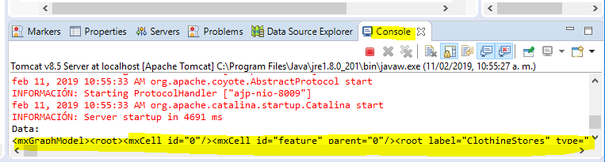

**Create a new service**

1. **(VariaMos services project).** Create a new Java class inside src/main/java/services called NewMicro.java with the next content

|  |
| --- |
| @Controller  public class NewMicro {    @CrossOrigin  @RequestMapping(value="/NewMicro/test", method=RequestMethod.POST, produces="text/plain")  @ResponseBody  public String micro(@RequestBody String data_collected) {  System.out.println("Data:"+data_collected);  return "Wow new micro working...";  }    } |

1. **(VariaMos web project).** Open src/components/model_actions/Verification.vue and apply the next modifications

After this line:

|  |
| --- |
| <a @click="test()" class="dropdown-item">Test sending the model</a> |

Add this line:

|  |
| --- |
| <a @click="test_micro()" class="dropdown-item">Test new service</a> |

Before this line:

|  |
| --- |
| test(){ |

Add this code:

|  |
| --- |
| test_micro(){  if (localStorage["domain_implementation_main_path"]) {  this.errors=[];  var encoder = new mxCodec();  var result = encoder.encode(this.current_graph.getModel());  var xml = mxUtils.getXml(result);  axios.post(localStorage["domain_implementation_main_path"]+'NewMicro/test', {  data: "test"  })  .then(response => {  var c_header = modalH3("Test response");  var c_body = modalSimpleText(response.data);  setupModal(c_header,c_body);  })  .catch(e => {  this.errors.push(e);  var c_header = modalH3(this.$t("modal_error"),"error");  var c_body = modalSimpleText(e + this.$t("model_actions_backend_problem"));  setupModal(c_header,c_body);  });  }else{  var c_header = modalH3(this.$t("modal_error"),"error");  var c_body = modalSimpleText(this.$t("verification_path_problem"));  setupModal(c_header,c_body);  }    }, |

1. **(VariaMos services project).** Restart the server.
2. **(VariaMos web project).** ClickVerification -> Test new service (menu option). You will see something like this.

